PocketSmart AI: AI-Powered Budget & Recommendation Assistant

Project Description:
PocketSmart AI helps people understand and control their spending. It reads messy UPI and card merchant strings such as "UPI-SWIGGY*BLR-9182", sorts them into ten spending categories, flags unusual charges, forecasts next-week spending per category and explains the results in plain English. Classical machine learning does all the numbers, and Google Gemini is used only to phrase the model output as friendly advice.
The project is built with Python 3.11, scikit-learn and statsmodels for the models, FastAPI with Pydantic validation for the five-endpoint API, the Gemini API for the advice layer and Streamlit for the interface. It is deployed on Google Cloud Run. All data is synthetic and generated with a seeded random generator, so every result in the README can be reproduced with one command. A local response cache and a template fallback keep the advice feature working even when the Gemini API is unreachable.

Scenarios
Scenario 1: A college student pastes ten merchant strings from a UPI statement. PocketSmart AI returns a category and a confidence score for each one, such as Food Delivery or Transport, so a confusing statement becomes an organised list in seconds.
Scenario 2: A working professional opens the forecast view before a festival month. The app shows the predicted spend per category for the coming week, compares it with simple baselines and explains in plain English which categories are likely to rise.
Scenario 3: A user checks the anomalies view and sees a charge far above the usual level for its category. The advice endpoint explains the flag in simple words, and if the Gemini API is unavailable the app still returns a clear template-based message instead of an error.

Technical Architecture:
Description: PocketSmart AI uses a modular layered architecture. The Streamlit interface (or the FastAPI /docs page) sends JSON requests over HTTPS to a FastAPI service running on Google Cloud Run. The service validates every request with Pydantic and calls the trained models, which are loaded once at start-up: a TF-IDF and Logistic Regression classifier, anomaly detectors (rolling z-score and Isolation Forest) and forecasters (Naive, Seasonal naive, Linear regression on lags and SARIMAX). The outputs are returned as JSON. For the advice endpoint the JSON is passed to the Gemini layer, which only rephrases it in English, caches the reply by input hash and falls back to a template string if the API call fails. Data, the trained model, evaluation results and the cache are stored as files.
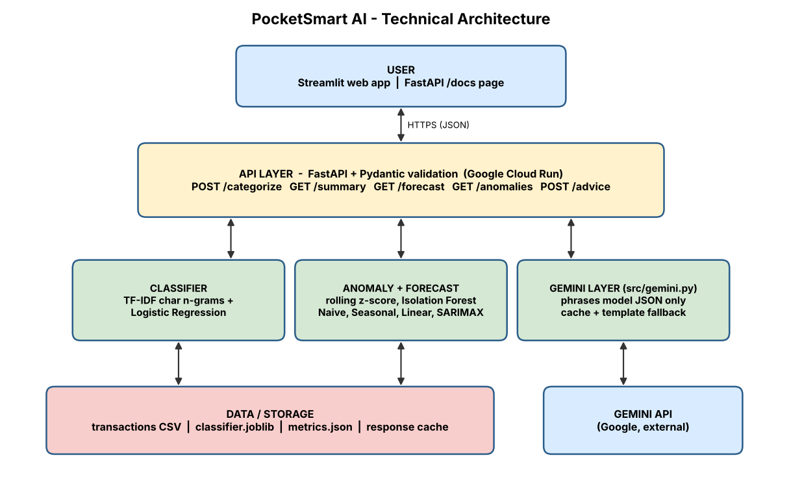
(Note: PocketSmart AI does not use a database, so an ER diagram is not required. Data is stored as CSV, joblib and JSON files.)

Pre-requisites:
- Python Programming Proficiency: Python Documentation (https://docs.python.org/3)
- FastAPI and Pydantic Knowledge: FastAPI Documentation (https://fastapi.tiangolo.com)
- Machine Learning Basics: scikit-learn Documentation (https://scikit-learn.org/stable)
- Time-Series Forecasting Basics: statsmodels Documentation (https://www.statsmodels.org)
- Gemini API Familiarity: Gemini API Documentation (https://ai.google.dev/gemini-api/docs)
- Streamlit Skills: Streamlit Documentation (https://docs.streamlit.io)
- Google Cloud Run Deployment: Cloud Run Documentation (https://cloud.google.com/run/docs)
- Version Control with Git: Git Documentation (https://git-scm.com/doc)

Project Workflow:

Milestone 1: Data, Model Selection and Architecture
- Activity 1.1: Create a Gemini API key and store it securely in the project environment.
- Activity 1.2: Research and select the models for classification, anomaly detection and forecasting.
- Activity 1.3: Define the architecture of the application, detailing the interaction between the UI, API, models and the Gemini layer.
- Activity 1.4: Set up the development environment and install the required libraries.

Milestone 2: Core Functionalities Development
- Activity 2.1: Generate seeded synthetic transaction data and train the merchant classifier.
- Activity 2.2: Build anomaly detection and weekly per-category forecasting, and consolidate all metrics into one evaluation report.

Milestone 3: API Development (api/main.py)
- Activity 3.1: Write the FastAPI application with the five endpoints and Pydantic schemas, loading the models once at module scope.

Milestone 4: Gemini Layer and Frontend Development
- Activity 4.1: Build the Gemini advice layer with a strict system prompt, response cache and template fallback.
- Activity 4.2: Build the Streamlit interface that calls the API.

Milestone 5: Deployment
- Activity 5.1: Prepare the application and run it locally.
- Activity 5.2: Deploy the application publicly on Google Cloud Run.
Milestone 6: Conclusion

Milestone 1: Data, Model Selection and Architecture
In this milestone we decide which models solve each part of the problem, define how the components talk to each other and prepare the working environment. A key design choice is to keep numbers and predictions inside classical machine-learning models, and to use the generative AI model only to phrase the results.

Activity 1.1: Generate a Gemini API Key
The advice layer needs a valid Gemini API key. Follow the steps below to create one and connect it securely to the project.
- Step 1 — Open Google AI Studio: Visit https://aistudio.google.com and sign in with your Google account.
- Step 2 — Create an API key: Open the "Get API key" section and click "Create API key" (select or create a Google Cloud project when asked).
- Step 3 — Copy the key: Copy the key immediately and store it safely. Do not share it or paste it into code.
- Step 4 — Add the key to the project: Create a .env file in the project root and add the key: GEMINI_API_KEY=your_key_here [confirm variable name]
- Step 5 — Keep the key out of git: Add .env to .gitignore so the key is never committed.
# .gitignore
.env
models/
data/*.csv
__pycache__/

[Insert screenshot: Google AI Studio API key page (hide the key value)]

Activity 1.2: Research and Select the Appropriate Models
The following points were considered to select the best model for each task:
- Merchant classification: Merchant strings are short and noisy, so TF-IDF character n-grams (2 to 4) capture spelling variations. Logistic Regression with balanced class weights is the baseline, and RandomForest is used for comparison.
- Anomaly detection: A per-category rolling z-score is compared against Isolation Forest, measured by precision and recall against a hidden ground-truth column.
- Forecasting: Weekly per-category totals are forecast with Naive, Seasonal naive, Linear regression on lags and SARIMAX. The last 8 weeks are held out by date and models are compared by MAE and MAPE.
- Advice generation: Google Gemini is used only to turn model JSON into plain English. It never computes or predicts numbers.

Activity 1.3: Define the Architecture of the Application
- Frontend: Users submit merchant strings or requests in the Streamlit app and see categories, summaries, forecasts, anomalies and advice.
- Backend: The FastAPI service validates requests with Pydantic, runs the pre-loaded models and returns JSON.
- AI integration: The Gemini layer receives model JSON under a strict system prompt (never compute, never predict, only phrase), checks the cache, calls the API and falls back to a template string on failure.
- Storage: Synthetic transactions (CSV), the trained model (joblib), evaluation results (JSON and PNG) and the response cache (JSON).

Activity 1.4: Set Up the Development Environment
- Install Python: Create a conda environment with Python 3.11.
conda create -n pocketsmart python=3.11
conda activate pocketsmart

- Install the libraries: Install the dependencies listed in requirements.txt.
pip install -r requirements.txt
python -c "import sklearn, statsmodels"

- Set up the project structure: Create the folders data, src, models, results and api, plus README.md and VIVA.md.
pocketsmart/
|-- data/generate.py
|-- src/ (features, train_classifier, anomaly, forecast, evaluate, gemini)
|-- models/classifier.joblib
|-- results/metrics.json
`-- api/main.py

Milestone 2: Core Functionalities Development

Activity 2.1: Generate Data and Train the Classifier
- Synthetic data generator: data/generate.py creates about 8,000 to 12,000 daily transactions over 30 months in 10 categories, with weekly, monthly and festival seasonality, messy Indian-format merchant strings and about 2% injected anomalies stored in a hidden ground-truth column. A fixed random seed makes it reproducible.
- Merchant classifier: src/features.py builds TF-IDF character n-gram features fit on the training split only. src/train_classifier.py trains Logistic Regression (balanced class weights), compares RandomForest, uses a time-based split and reports per-class precision, recall and a confusion matrix. The vectorizer and model are saved together as models/classifier.joblib.
python data/generate.py
python src/train_classifier.py

[Insert screenshot: terminal output showing classifier accuracy and per-class report]

Activity 2.2: Anomaly Detection, Forecasting and Evaluation
- Anomaly detection: src/anomaly.py compares a per-category rolling z-score with Isolation Forest and reports precision and recall against the ground truth.
- Forecasting: src/forecast.py trains Naive, Seasonal naive, Linear regression on lags and SARIMAX models and prints a results table with MAE and MAPE.
- Evaluation report: src/evaluate.py with the --report flag regenerates every README number and writes results/metrics.json, a confusion matrix PNG and a forecast plot PNG.
python src/evaluate.py --report

[Insert screenshot: confusion matrix image and forecast plot from the results folder]

Milestone 3: API Development (api/main.py)
This milestone builds the FastAPI application that exposes the models. Models are loaded once at module scope, and every request and response uses a Pydantic schema.

Activity 3.1: Writing the Main Application Logic in api/main.py

Define the Endpoints:
- POST /categorize: merchant string(s) in, categories and confidence out.
- GET /summary: category breakdown for a period.
- GET /forecast: next-period prediction per category.
- GET /anomalies: flagged transactions.
- POST /advice: sends model output to the Gemini layer and returns plain-English advice.

Validation and Error Handling:
- Pydantic schemas reject malformed input with clear errors.
- If the Gemini call fails, the /advice endpoint returns the template fallback instead of an HTTP 500.
uvicorn api.main:app --reload
# open http://127.0.0.1:8000/docs

[Insert screenshot: FastAPI /docs page listing the five endpoints]

Milestone 4: Gemini Layer and Frontend Development

Activity 4.1: Building the Gemini Advice Layer (src/gemini.py)
- Strict system prompt: The model is told never to compute, never to predict and only to phrase the numbers it is given.
- Response cache: Replies are stored in a local JSON file keyed by a hash of the input, so repeated requests are instant and use no API quota.
- Template fallback: If the API is unreachable, a template string built from the model output is returned.

Activity 4.2: Building the Streamlit Frontend
- Interface: A simple page where the user enters merchant strings, picks a view (summary, forecast, anomalies) and reads the advice. It calls the FastAPI endpoints and displays tables and plain-English text.
streamlit run <frontend file> # [confirm filename]

[Insert screenshot: Streamlit interface showing categorized transactions]

Milestone 5: Deployment
In Milestone 5 the application is first run locally to confirm it works and is then deployed to Google Cloud Run so that anyone can open it from a public URL.

Activity 5.1: Local Testing
- Start the API with uvicorn and the UI with Streamlit, then test categorization, summary, forecast, anomalies and advice.
- Disconnect the internet and call /advice to confirm that the template fallback works and no error is returned.

Activity 5.2: Deploy to Google Cloud Run
- Prepare gcloud: Install the Google Cloud CLI, sign in and select the project.
- Deploy from source: Cloud Build builds the container automatically (it handles the amd64 architecture), and the Gemini key is set as an environment variable instead of being baked into the image.
gcloud run deploy pocketsmart --source . --region <region> --allow-unauthenticated
gcloud run services update pocketsmart --set-env-vars GEMINI_API_KEY=<your key>

- Cold starts: The service uses min-instances=0, so warm it up with one request before a demo.
- Verify: Open the public URL from a phone on mobile data and record the URL: [Cloud Run public URL]
[Insert screenshot: Cloud Run service page showing the live URL]

Exploring the Website’s Web Pages:

Home / Input Page:
Description: The landing view of PocketSmart AI where the user pastes merchant strings or chooses a sample dataset. It explains in one line that the data is synthetic and lets the user choose between categorization, summary, forecast and anomaly views.
[Insert screenshot: home / input page]

Categorization and Summary Page:
Description: Shows each merchant string with its predicted category and confidence, followed by a category breakdown for the selected period.
[Insert screenshot: categorization and summary page]

Forecast and Anomalies Page:
Description: Displays the next-week forecast per category compared with the baselines, and the list of flagged transactions with the reason they were flagged.
[Insert screenshot: forecast and anomalies page]

Advice Section:
Description: Shows the plain-English advice generated by the Gemini layer (or the template fallback) beneath the results, written in simple language the user can act on.
[Insert screenshot: advice section]

Conclusion:
PocketSmart AI shows how classical machine learning and generative AI can work together in a safe way: models handle categorization, anomaly detection and forecasting, while Gemini only explains the results in plain English. The FastAPI service, Streamlit interface and Google Cloud Run deployment make the project easy to run, test and share. With a reproducible evaluation report, a fallback for every external call and a clear roadmap towards real bank data, user accounts and multilingual advice, the project is ready to grow beyond its first demonstration.

